Tony Trotter

5/30/22

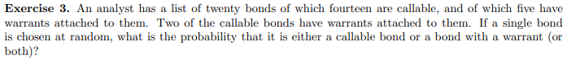





Probability of Default

$$P\left(B_{1}∩B_{2}∩B_{3}∩B_{4}\right)=P\left(B_{1}\left|B_{2}\right|B_{3}|B_{4}\right)=.24*.24*.24*.24=.00332$$

Probability of Non-Default





is the set of all possible outcomes.

If , then $x∈A/Bor x∈B/Aor x∈A∩B$ shown below:

$A/B=A-A∩B$ and $B/A=B-A∩B$

Then $P\left(A∪B\right)=P\left(A∕B\right)+P\left(B∕A\right)+P\left(A∩B\right)$

$=P\left(A\right)-P\left(A∩B\right)+P\left(B\right)-P\left(A∩B\right)+P\left(A∩B\right)$

= P(A) + P(B) – 2\*P( $A∩B)$ + P($A∩B)$

$=P\left(A\right)+P\left(B\right)-P\left(A∩B\right) as intended ⊠$ The reverse direction is similar